
Angeles University

Foundation

Training Enrollment

System

A Multi-Table PHP PDO Application
Laboratory Activity Documentation
IPT — Integrative Programming and Technology
Name: [Sarno, James Andrei A.]
Section: [BSIT 3A]
GitHub repository: [https://github.com/eternalmatrix146-collab/ipt10-lab-01.git]

1. Project Description
The Training Enrollment System is a web application for an organization that offers training programs. It is built with PHP and PDO and uses a MySQL database with four related tables.
One Administrator uses the system to:
- Manage courses — add, edit and delete courses.
- Manage classes — each class belongs to a course and has a schedule, an instructor and a number of available slots.
- Record a student — save a new student and enroll them into a class in one step.
- Enroll an existing student into another class.
- View enrollments joined with student, class and course details, with search, status filter and paging.
- Cancel an enrollment — the slot goes back to the class.
- View a report of active and cancelled enrollments per class.
The system follows three rules:
- No over-enrollment. A class with 0 slots shows "No slots available."
- No duplicate enrollment. A student cannot have two active enrollments in the same class.
- Data stays consistent. Recording a student and cancelling an enrollment each run inside one database transaction. If any step fails, every change is rolled back.
All database work uses PDO with prepared statements.

2. Setup Instructions
Requirements: XAMPP (Apache, MySQL, PHP 7.4 or newer) and a web browser.
- Copy the project folder into XAMPP so the path is C:\xampp\htdocs\training_enrollment\
- Open the XAMPP Control Panel and start Apache and MySQL.
- Open http://localhost/phpmyadmin, click Import, choose the file sql/schema.sql and click Import. This creates the training_db database with sample data.
- Copy config/db.sample.php and name the copy config/db.php. The XAMPP defaults (user root, empty password) already work.
- Open http://localhost/training_enrollment/
- Log in with username admin and password admin123.

3. Database Design
The database has four tables. Foreign keys connect them so the data stays consistent.
Table | What it stores | Relationship
courses | Course code, name and description | One course has many classes
classes | Class code, schedule, instructor and slots still available | Belongs to a course (course_id)
students | Full name, email and phone | One student has many enrollments
enrollments | Which student is in which class, the date and the status (active or cancelled) | Belongs to a student (student_id) and a class (class_id)

The enrollments table connects students and classes. One student can join many classes, and one class can have many students.

4. Design Patterns
This project uses two design patterns: Singleton and Repository.

4.1 Singleton — Database class
What it is. A Singleton is a class that can only ever have one object.
How it is used. The constructor of the Database class is private, so no page can create it with "new". The only way to get it is Database::getInstance(). The first call creates the connection. Every later call returns the same object.
// config/db.php
$db = Database::getInstance($dsn, $user, $pass);
Why I used it:
- One connection per request. Every class shares the same connection, which is faster than opening a new one each time.
- Transactions need it. A transaction belongs to one connection. Recording a student changes three tables. Because all steps use the same connection, a rollback can undo all of them.
- One place for settings. The error mode and fetch mode are set once.

4.2 Repository — EnrollmentRepository class
What it is. A Repository is a class that holds all the database code for one topic. Pages ask the repository to do something. They do not write SQL themselves.
How it is used. EnrollmentRepository owns everything about enrollments:
Method | What it does
recordStudent() | Inserts the student, inserts the enrollment and takes one slot, in one transaction
enroll() | Enrolls an existing student and takes one slot, in one transaction
cancel() | Sets the status to cancelled and gives the slot back, in one transaction
allWithDetails() | Lists enrollments joined with student, class and course
search(), countSearch() | The same list with search, status filter and paging
summaryByClass() | The report: active and cancelled enrollments per class

Why I used it:
- Pages stay simple. Files in the admin folder only read the form, validate it, call one method and show a message.
- The transaction rule is written once. No page can forget a step or do the steps in the wrong order.
- Easy to change. If a table changes, only the repository changes.

4.3 How the transaction works
Recording a student runs these steps inside one transaction:
beginTransaction()
1. Check the class still has slots -> if not: "No slots available."
2. INSERT INTO students
3. INSERT INTO enrollments
4. UPDATE classes SET slots = slots - 1
commit()

If anything fails -> rollBack()
(no student row, no enrollment row, slots unchanged)
Cancelling an enrollment works the same way with two steps: set the status to cancelled, then add one slot back to the class.

5. Screenshot Evidence
Before you start: import sql/schema.sql again so the sample data is fresh. Take the screenshots in order (1 to 9) because later ones depend on earlier ones. Include the browser address bar in every capture. Delete this paragraph and all "How to capture" steps when you are done.

Screenshot 1 — Course Management
How to capture:
- Open http://localhost/training_enrollment/admin/courses.php
- Capture the page showing the Course List.
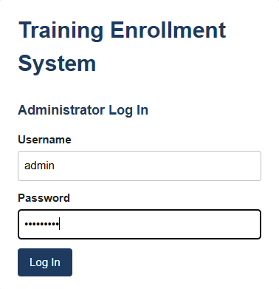
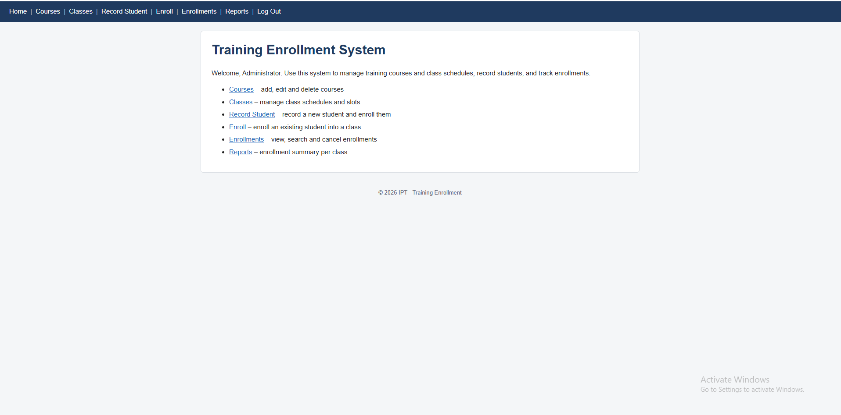

Screenshot 2 — Add / Edit Course Form
How to capture:
- On the Courses page, type a new course in the form (for example Code: PY101, Name: Python Basics). Capture it before clicking the button (2a).
- Click Add Course. Capture the "Course added." message and the new row in the list (2b).

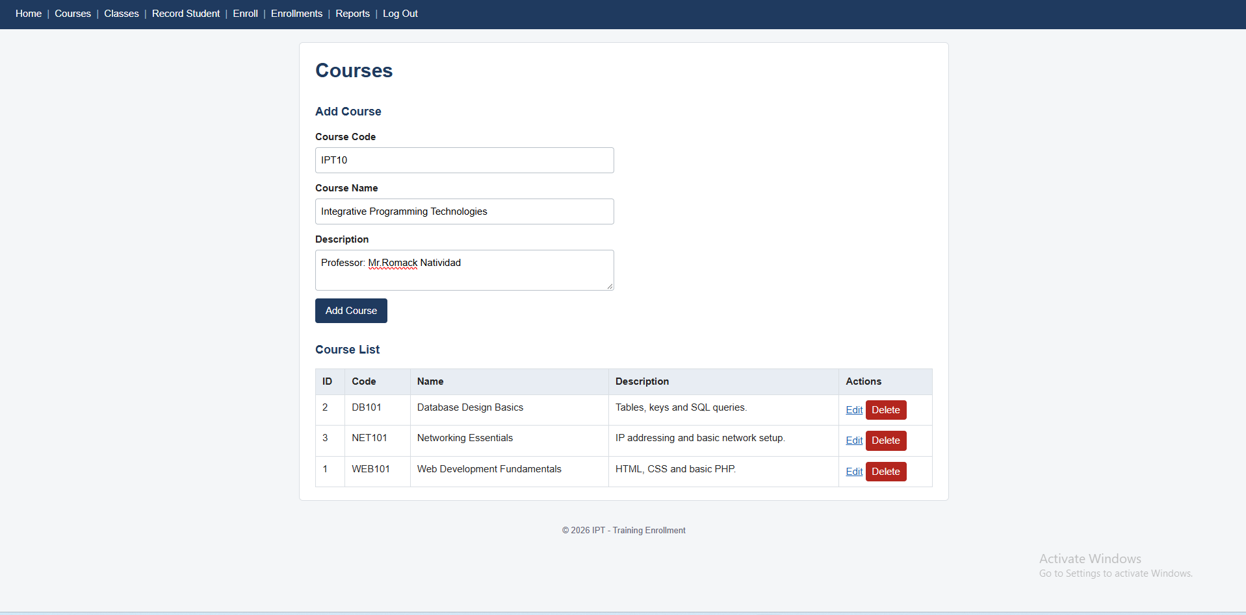
Figure 1a. Add Course form filled in with a new course.

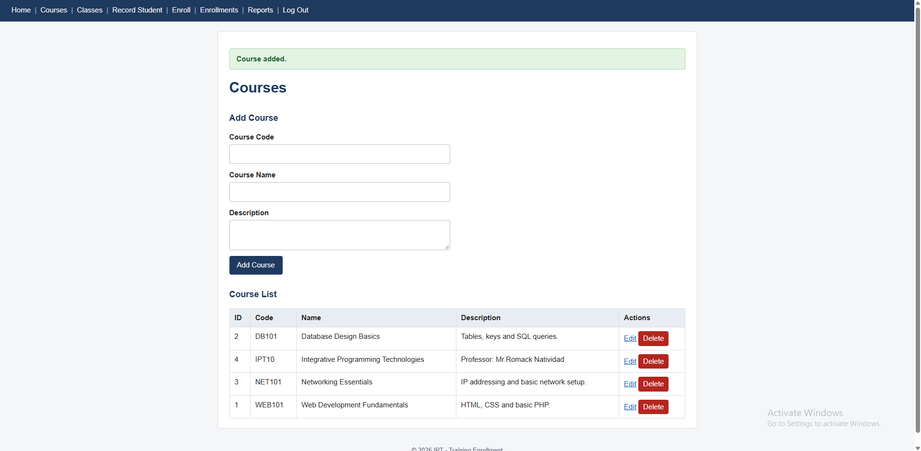
Figure 2b. Course list after saving, showing the new course and the success message.

Screenshot 3 — Class Management
How to capture:
- Open admin/classes.php
- Capture the Class List showing course, schedule and Slots Left. Note that WEB101-A has 5 slots.

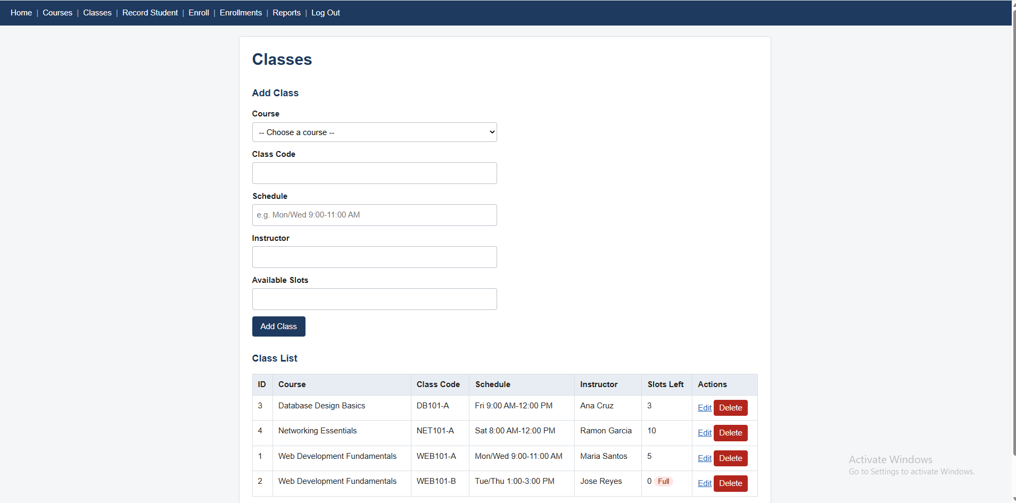
Figure 3. Classes page showing each class with its course, schedule and remaining slots.

Screenshot 4 — Student Recording Form
How to capture:
- Open admin/students.php
- Fill in a name, email and phone, and choose class WEB101-A (5 slots left).
- Capture the filled form before clicking Record Student.

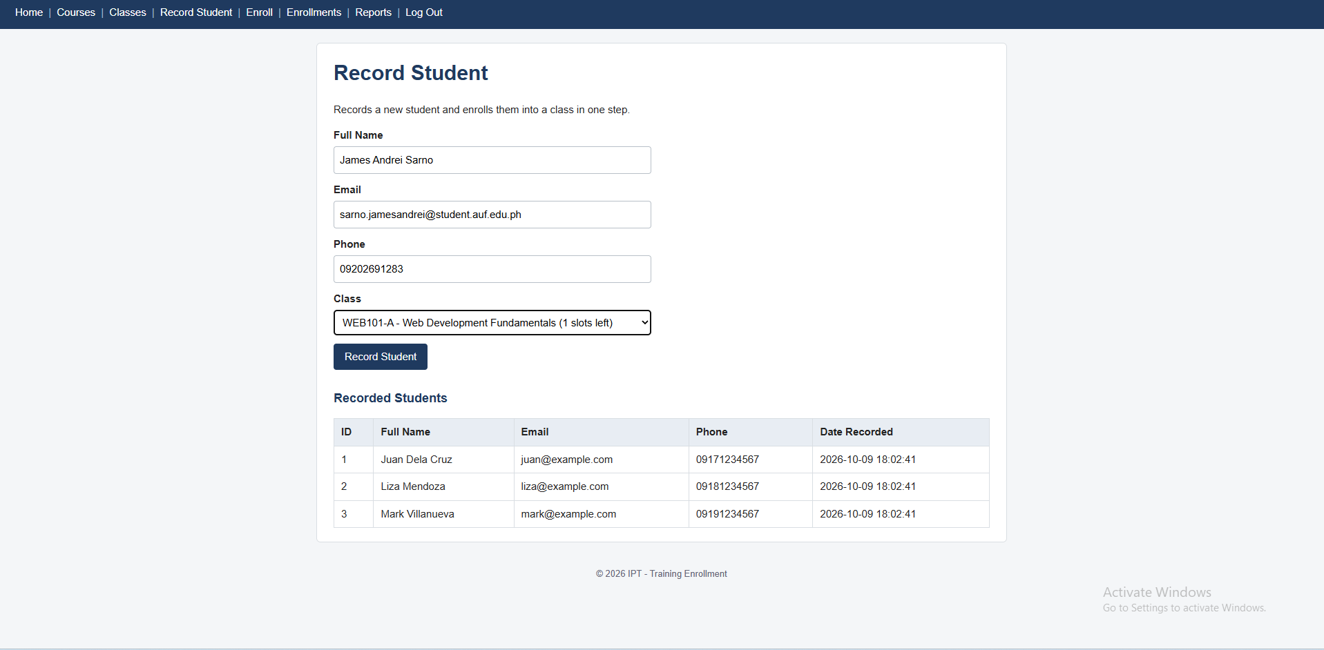
Figure 4. Student recording form with name, email, phone and the selected class.

Screenshot 5 — Successful Recording
How to capture:
- Click Record Student. Capture the green message and the new row in the Recorded Students table (5a).
- Open Enrollments. Capture the new enrollment row at the top (5b).

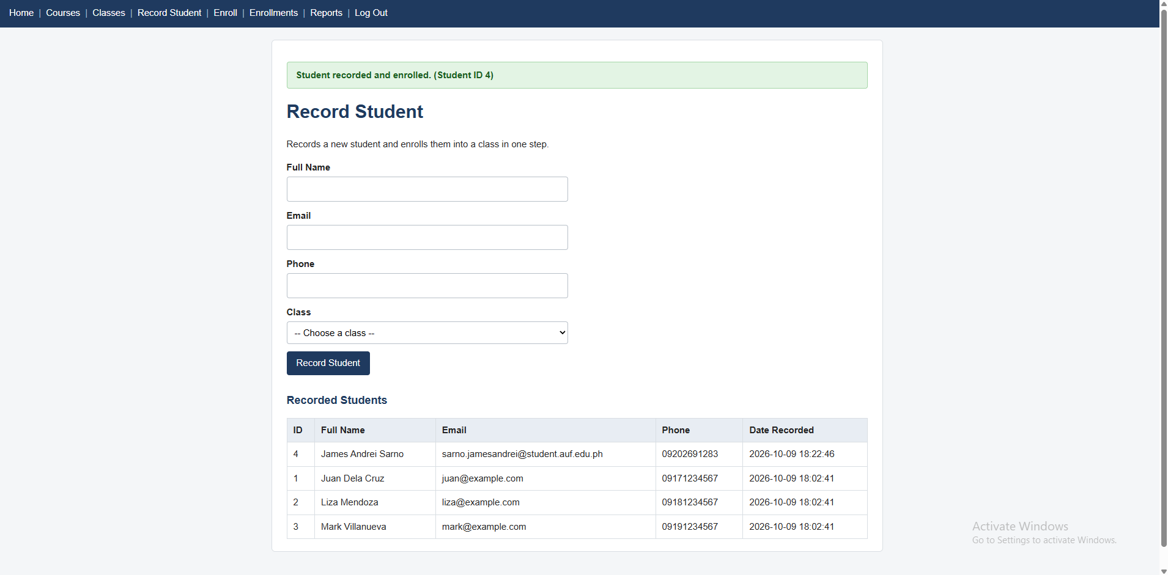
Figure 5a. Confirmation message and the new row in the students list.

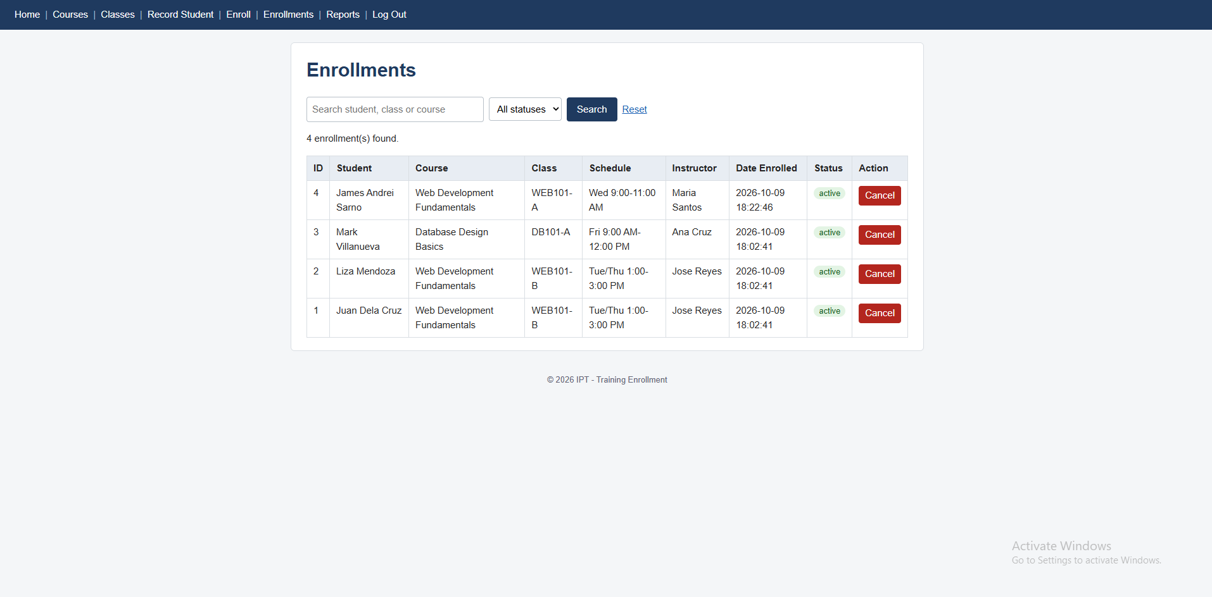
Figure 5b. The new row in the enrollments list.

Screenshot 6 — Enrollments List
How to capture:
- Open admin/enrollments.php
- Capture the table showing student, course, class, schedule, instructor and status.

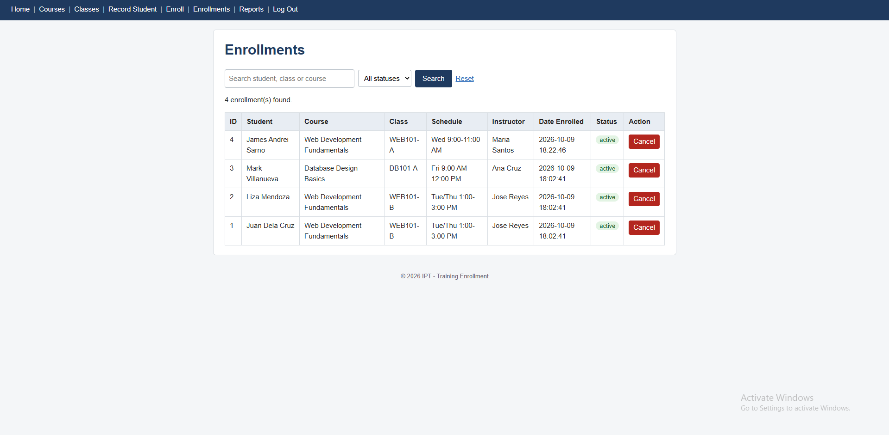
Figure 6. Enrollments list joined with student, class and course details.

Screenshot 7 — Cancelled Enrollment
How to capture:
- On the Enrollments page, click Cancel on the enrollment you made in Screenshot 5 and confirm.
- Capture the message and the row now showing status "cancelled" (7a).
- Open Classes. Capture WEB101-A back to 5 slots left (7b).

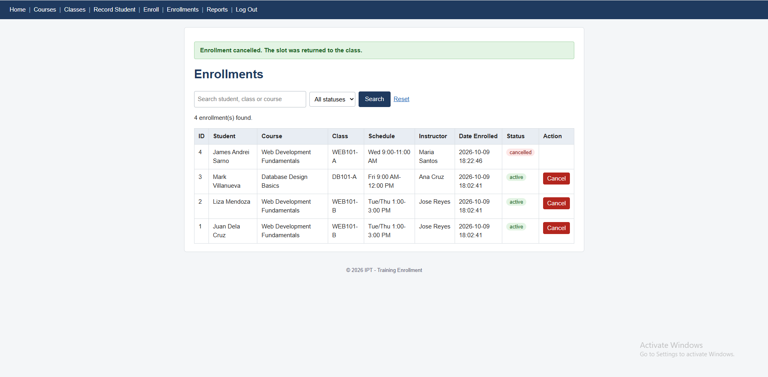
Figure 7a. Enrollment with status cancelled.

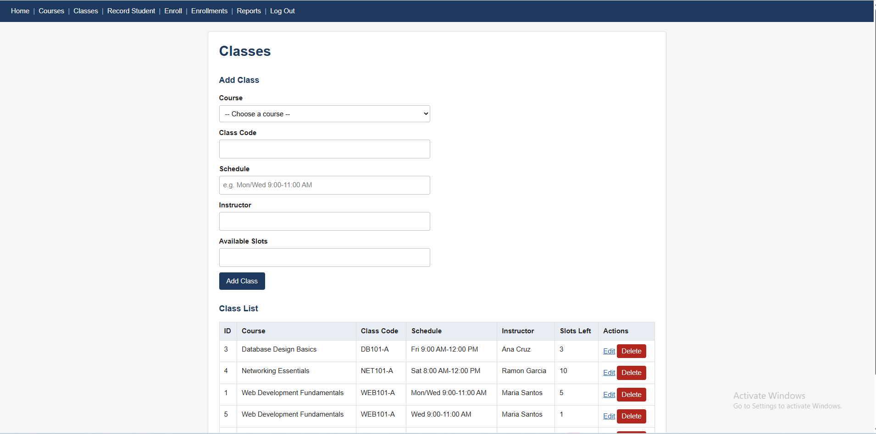
Figure 7b. Class WEB101-A with its slot restored (4 became 5).

Screenshot 8 — Rollback Case
How to capture:
- Open Record Student. Type a new name (for example "Rollback Test") and choose class WEB101-B (FULL).
- Click Record Student. Capture the red "No slots available. Nothing was saved." message together with the Recorded Students table below it. The new name must not be in the table (8a).
- Open Enrollments. Capture the list showing that no new enrollment was added (8b).

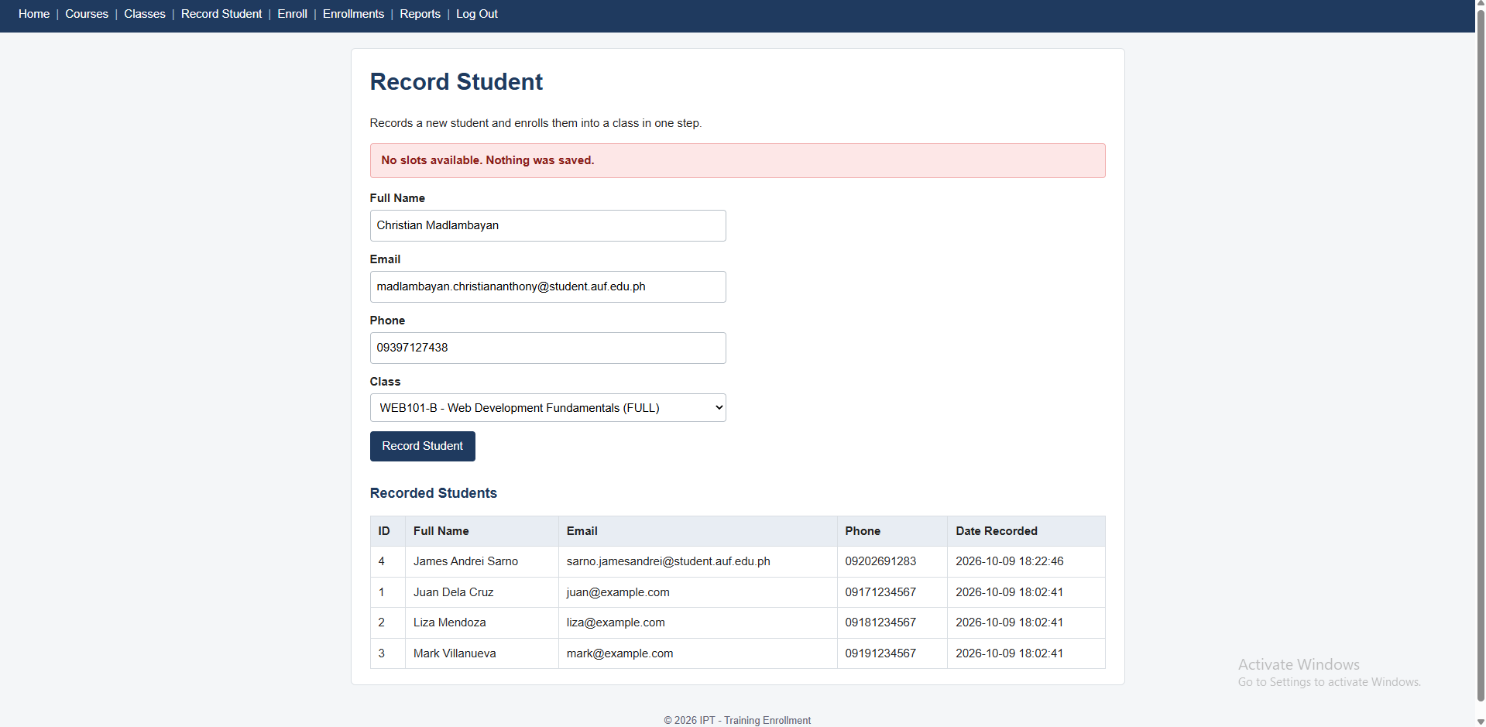
Figure 8a. "No slots available" message when recording into a full class. The student was not saved.

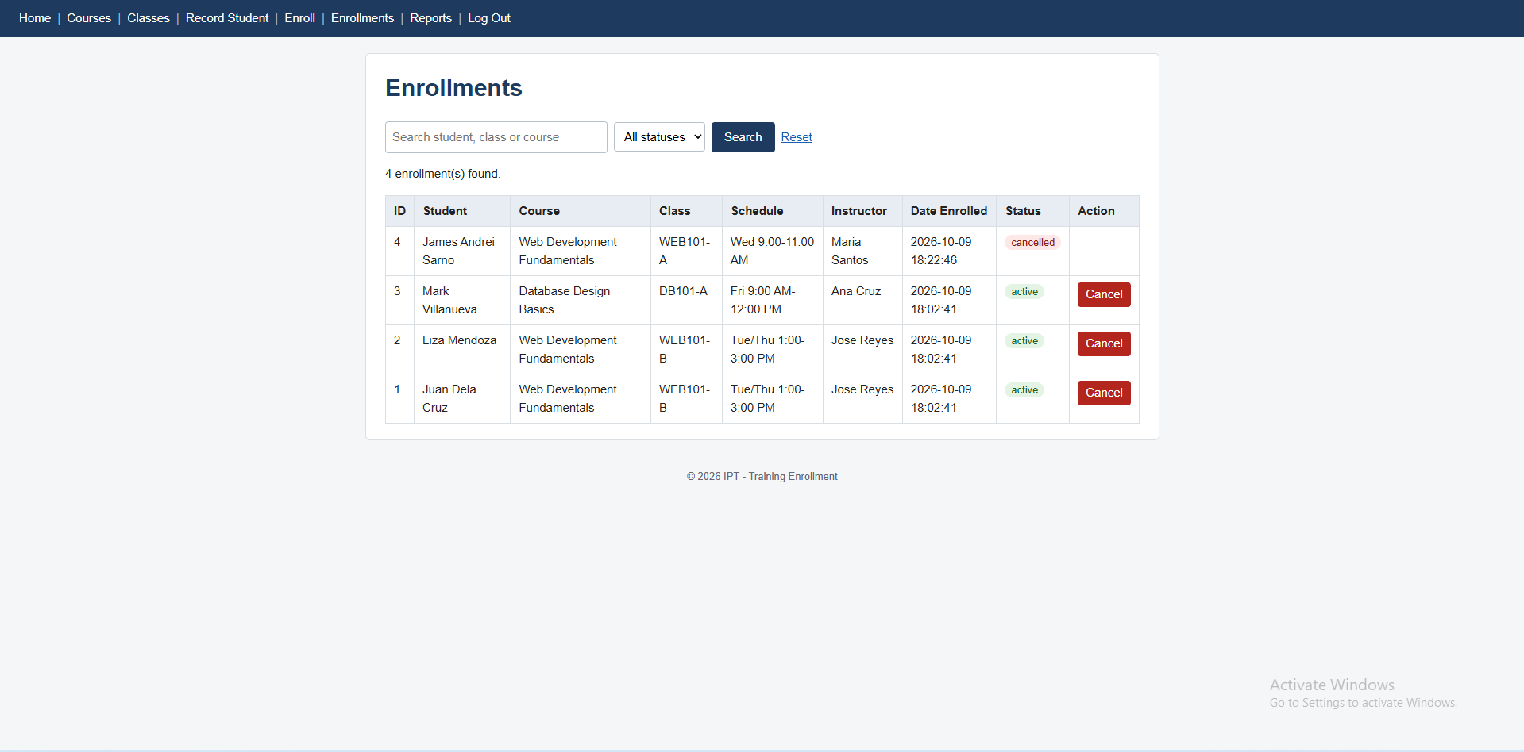
Figure 8b. Enrollments list with no new row, proving the transaction was rolled back.

Screenshot 9 — Database Evidence
How to capture:
- Open http://localhost/phpmyadmin and click the training_db database.
- Click the students table and capture the rows (9a).
- Click the enrollments table and capture the rows (9b).
- Click the classes table and capture the rows (9c).

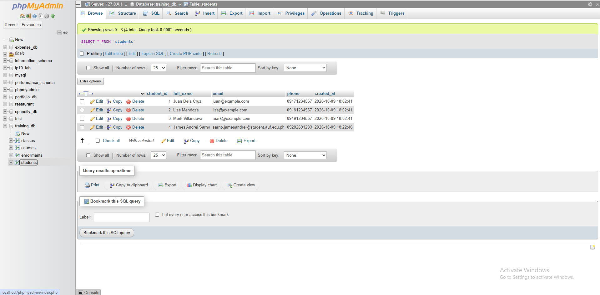
Figure 9a. phpMyAdmin view of the students table.

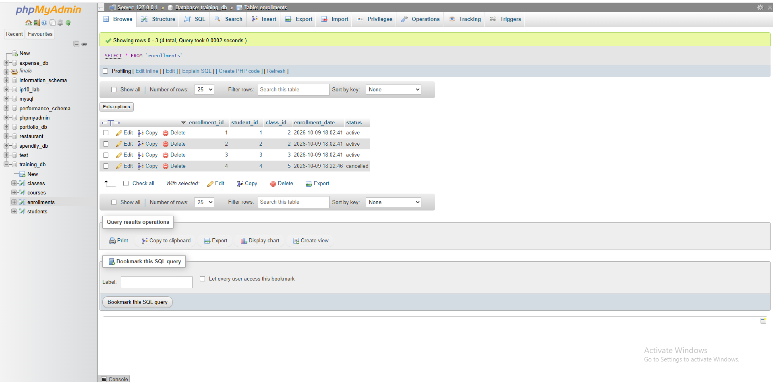
Figure 9b. phpMyAdmin view of the enrollments table.

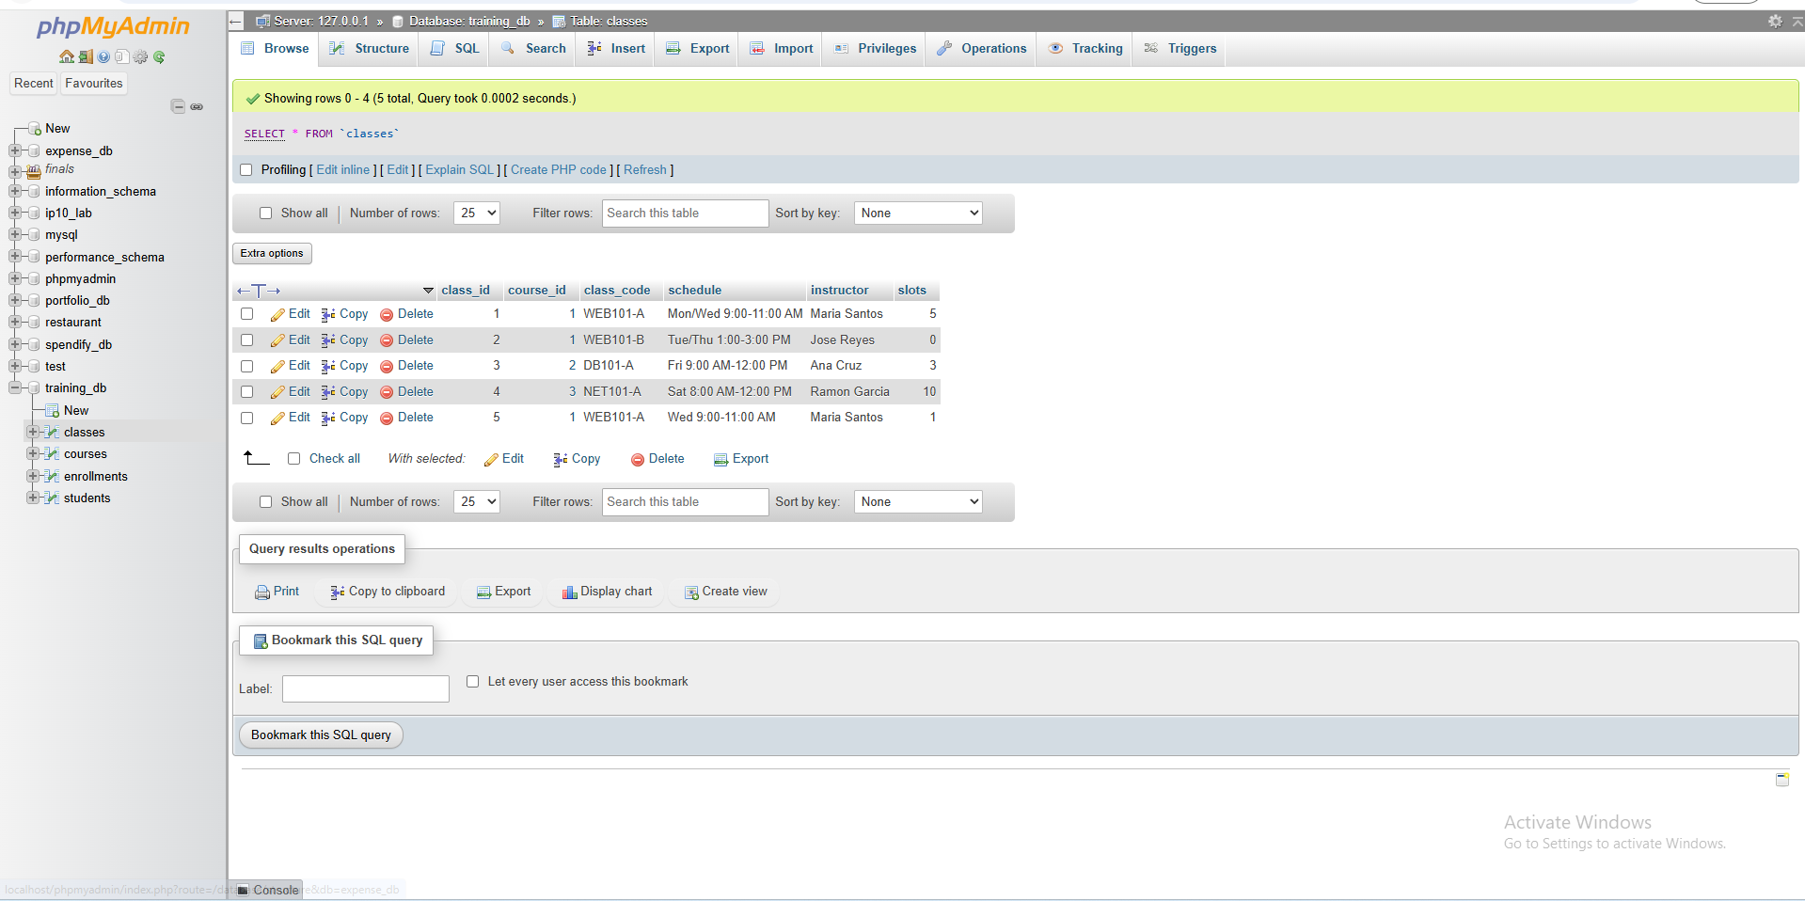
Figure 9c. phpMyAdmin view of the classes table.

